**Image Analysis and Computer Vision Homework**

Mohanad Diab

December 2022

* **Part 1: Theory**

**1.1: Problem formulation:**

In this homework, one is expected to prove in bot theoretical and practical parts his holistic understanding of the course, the first theoretical part poses the problem of a right symmetrical cone described in the problem script.

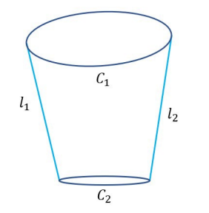

Picture (1.1.1): The picture of the contours of the cone.

It is expected to solve the following requirements:

1. From 𝐶1, 𝐶2 find the horizon (vanishing) line ℎ of the plane orthogonal to the cone axis.
2. From 𝑙1, 𝑙2, 𝐶1, 𝐶2 find the image projection 𝑎 of the cone axis.
3. From 𝑙1, 𝑙2, 𝐶1, 𝐶2 (and possibly ℎ and 𝑎), find the calibration matrix 𝐾.
4. From ℎ and 𝐾, determine the orientation of the cone axis wrt to the camera reference.
5. How would you use 𝐾, ℎ, the axis orientation and the image 𝑉 of the cone vertex in order to compute the cone semi-aperture angle α?

**Assumptions:**

1. It is assumed that the inputs in the image are determined in image coordinates and the parameters of C1, C2, L1, L2 have been extracted apriori.
2. The parameters won’t have numerical values, rather simple symbolic denotations.

**1.2: Scene inspection and preliminary analysis:**

The scene at first looks quite simple, but it is troublesome to deal with on a practical sense, since the scene has no parallel lines whatsoever, and the picture distorts the scene in a projective manner, with noticeable shear like rotation to the left side of the cone, which renders the upper cone C1 with somewhat of a slanted angle, and L1, L2 which are supposed to be symmetrical around the cone axis are not of the same length or angle, and finally we can notice that the cone axis is not upright with respect to the centers of the first cone C1, and the second cone C2.

**1.3: Action plan:**

Looking at the previous analysis and the problem requirements, it is possible to solve the problem using projective geometry and some camera geometry.

For the first requirements, we can take advantage of the fact that we have two cones and intersect them solving for the circular points, which in turn lie on the line of infinity of the plane orthogonal to the symmetry axis, then we can find their cross product to get the line at infinity parameters.

For the second problem, we can use some projective geometry relation of points and lines and incidence relation to find the center of both cones and then find the line connecting both of them which will represent the cone axis α.

For the third problem, we can use the line at infinity and some orthogonal lines to find the Image of the Absolute Conic (IAC), and perform Cholesky’s factorization to find the calibration matrix (K).

From the properties of K, we know the center of the projection, and can measure the angle between two directions, namely the cone axis and the central projection to find the orientation of the cone axis with respect to the camera reference.

For the 5th requirement, it would be useful to measure the angle between a translated cone axis and the slanted lines L1, L2.

**1.4: Geometrical solution:**

Problem 1. From 𝐶1, 𝐶2 find the horizon (vanishing) line ℎ of the plane orthogonal to the cone axis:

Assuming we already know the geometrical properties of the cones C1, C2 defined as follows:

Which can also be represented as:

For both conics it is assumed that all their parameters are known, leading to the expression:

Where:

If we intersect the two cones, we have two expressions with 2 unknowns, but are quadratics, which will result in a real/imaginary number configuration, them being the circular points of the conics of the image, which live on the line at infinity.

But we already know that the circular points lie on the line at infinity, which makes the line of infinity easily definable as:

This line will be referred to as h from now on as stated in the problem text.

One other way to do it, which is adopted in the Matlab implementation, is to find the dual conics of both conics, then exploit their intersection.

This way, the output will be 4 lines common to the dual conics derived from C1, C2:

Where C1d, C2d denote the image of the dual conics of conics C1 and C2, respectively, by intersecting them, we also save the trouble of finding L1 and L2 since they are by definition on of the 2 lines of the intersection between C1d and C2d.

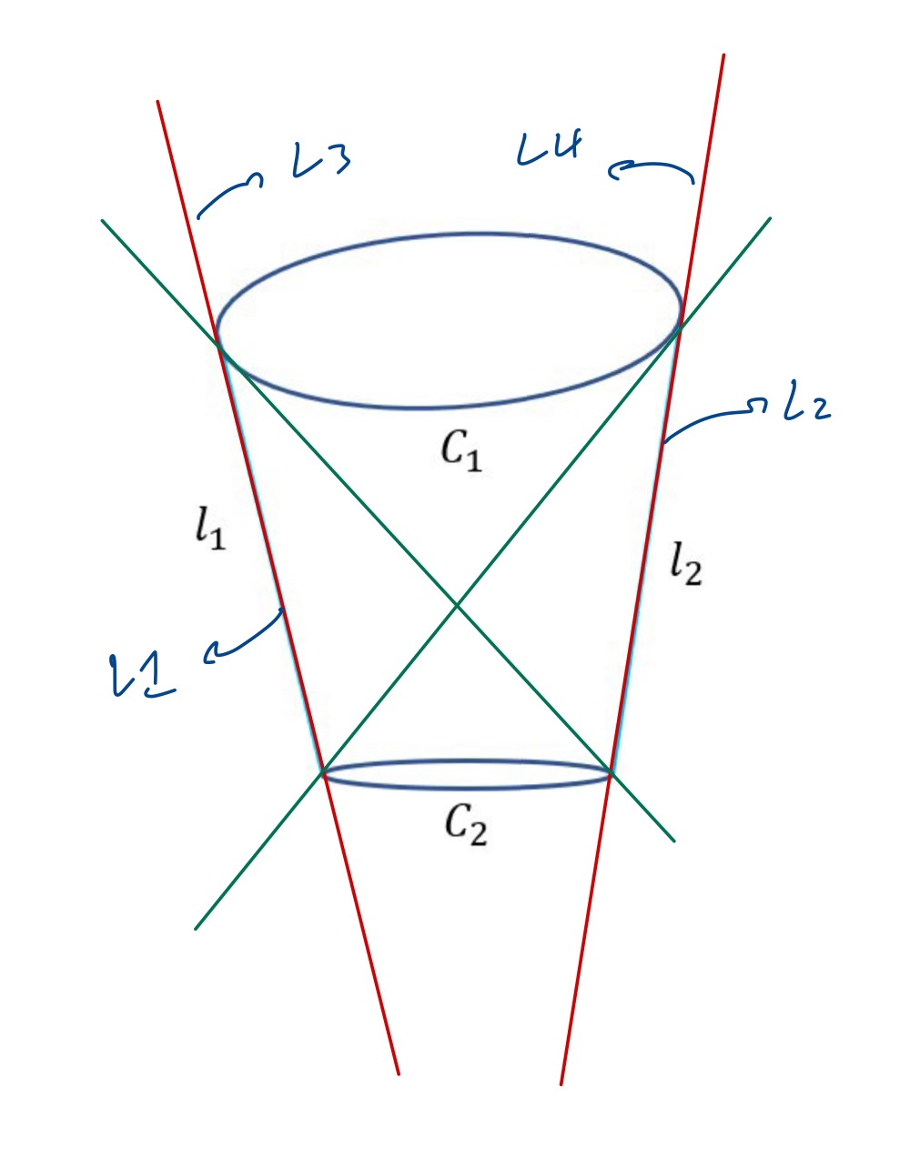

Picture (1.4.1): Lines obtained from intersecting dual conics

With the same rationale, we can find the line at infinity from the cone major and semi axis, since they are on the plane orthogonal to the cone\s axis, and they correspond to orthogonal directions in real life, which will prove helpful in the upcoming questions.

We can intersect both the conics’ major and semis axis’ to get vanishing points in the plane orthogonal to the cone’s axis, assume the cone’s axis is in the y direction in real life, this means that the major axis locations correspond to the x axis and the minor to the z axis.

Finding the vanishing points in both directions can lead to the line at infinity by the cross product of both points.

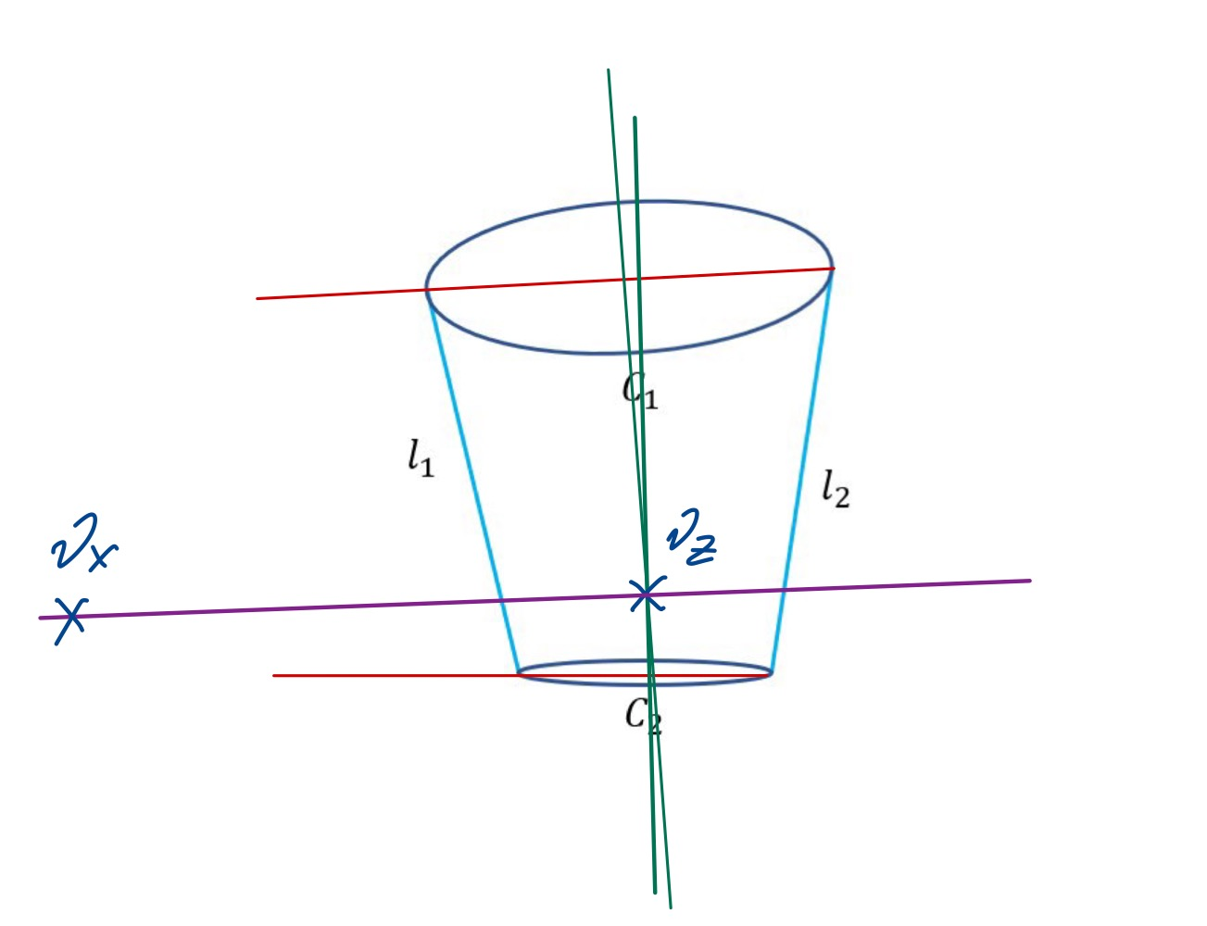

Picture (1.4.2): Line at infinity obtained from vanishing points vx, vz

Problem 2. From 𝑙1, 𝑙2, 𝐶1, 𝐶2 find the image projection 𝑎 of the cone axis.

For this part we are going to rely on projective geometry a little bit more to define a solution.

First of all, we need to address the problem that the cone axis is not easily recognizable in the image since C1 is subjected to some angular shift, while the conic C2 is upright with zero rotation, which would make the cone axis itself a little bit slanted with respect to the normal to the conic C2.

Since line L1, and L2, are the contours of the cone’s straight line, we can use them to connect a line that cuts each conic in their respective center with the following steps:

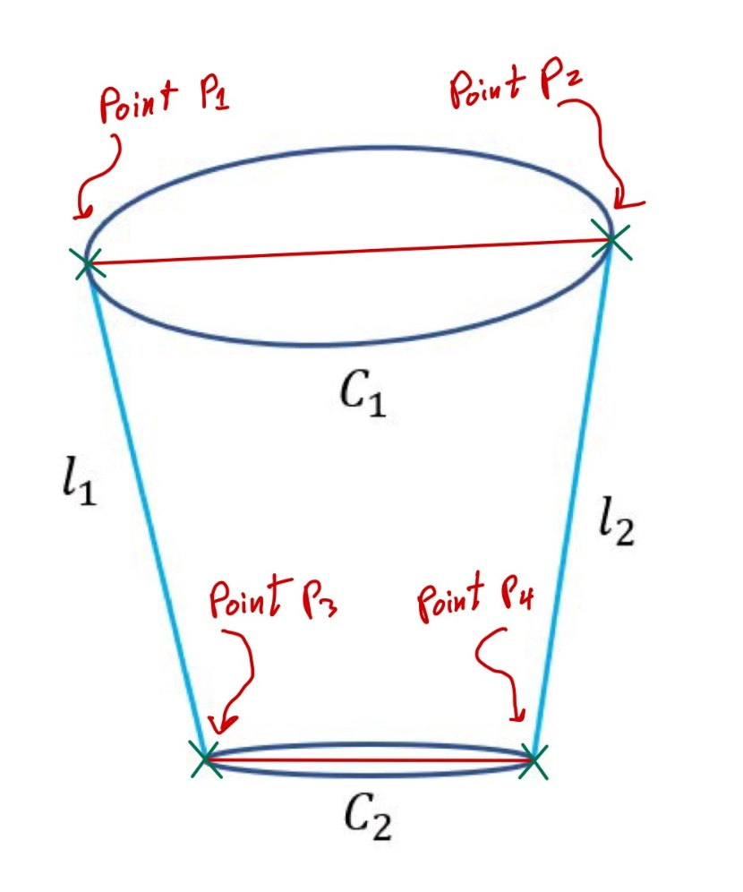

Picture (1.4.3): Points obtained from intersecting lines and conics

For the next step, we use the linear combination of two points to obtain a third point on the line joining the two points, and by setting the coefficients of both points to 0.5, we can obtain the point representing the center of the line:

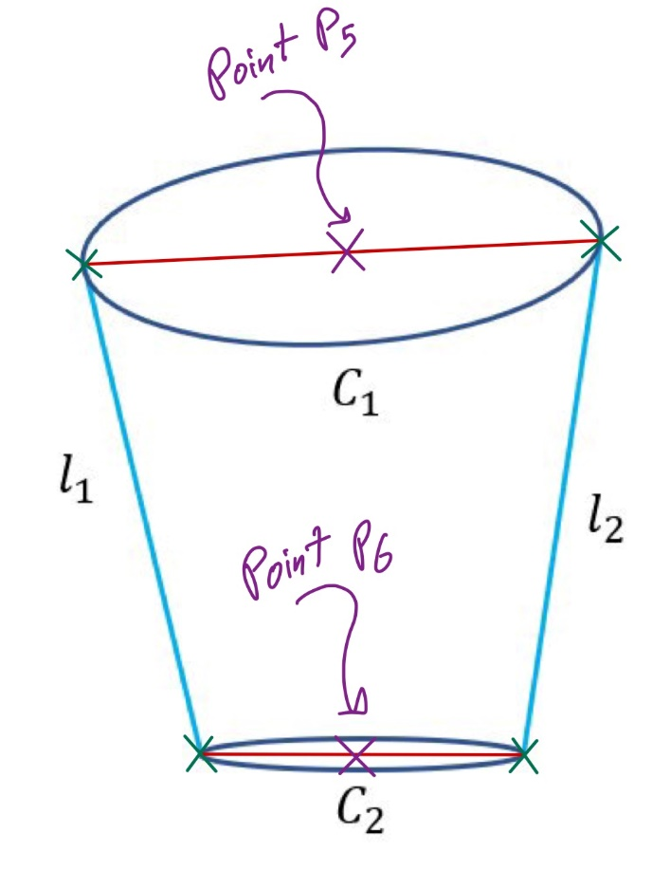

Picture (1.4.4): Points obtained from linearly combining two points

As for the next step, it’s pretty straight forward, we can use the cross product of both points to obtain the line representing the cone axis.

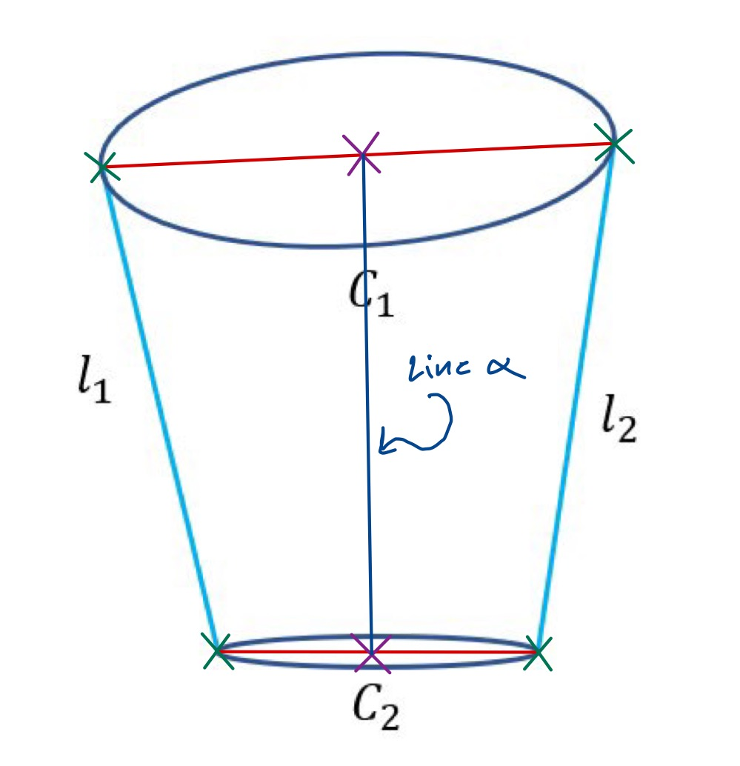

Picture (1.4.5): Line obtained from the cross product of two points.

Just like in the first questions, a different approach can lead to the same result, we can exploit L1 and L2 found in the first point, and intersect them finding the Vertex (V) of the cone, which can then be used as a point and intersect it with either conics’ centers to get the same result:

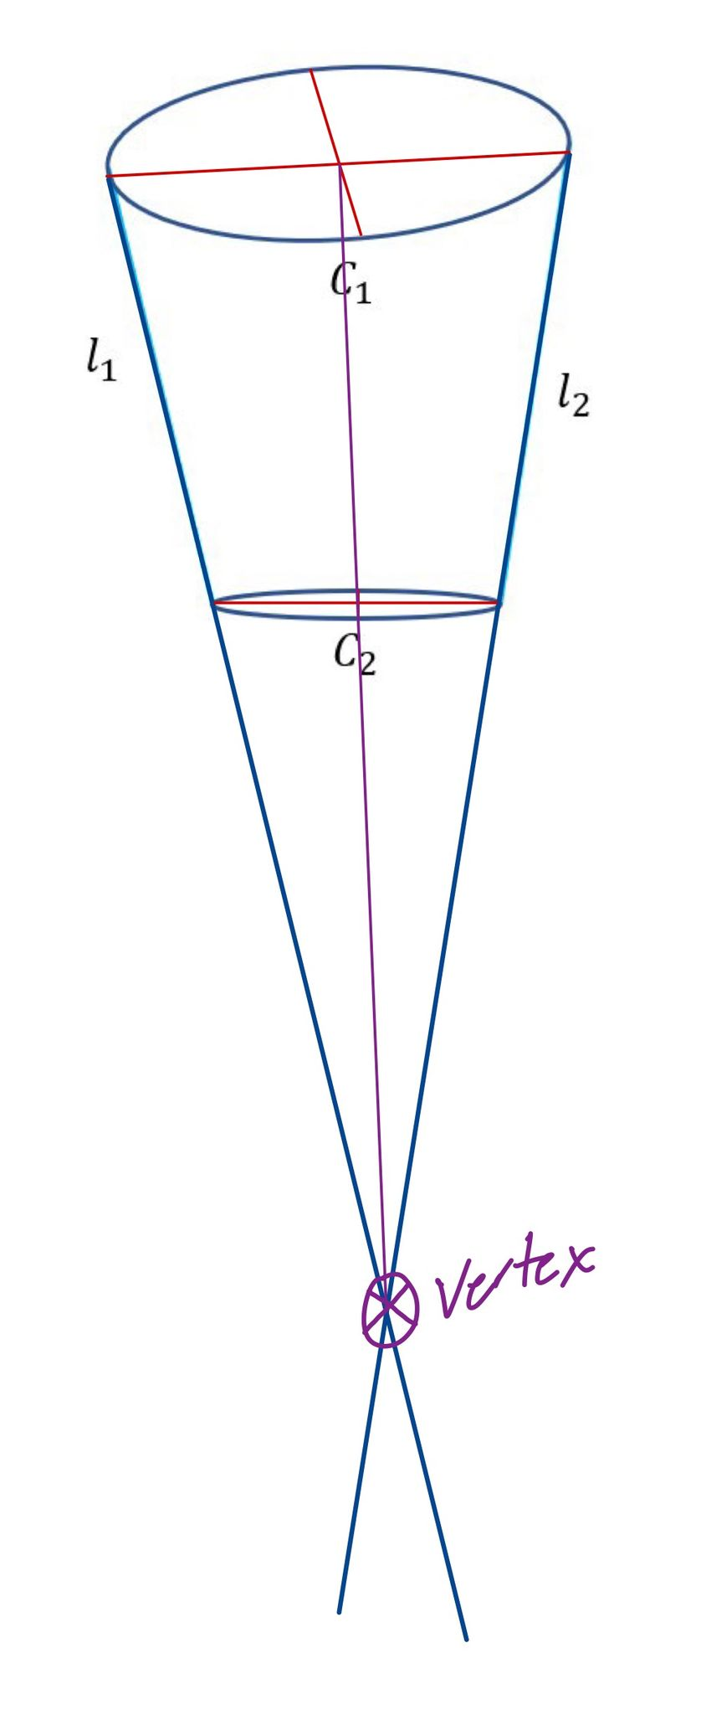

Picture (1.4.6): Vertex from L1, L2 intersection and then center intersection

Problem 3. From 𝑙1, 𝑙2, 𝐶1, 𝐶2 (and possibly ℎ and 𝑎), find the calibration matrix 𝐾.

The calibration matrix of a natural camera with no skew is a 3x3 matrix with 3 unknowns as stated in the problem text.

Since the cone is axially symmetric, we know that the lines produced on the previous problem along with the cone’s axis are all orthogonal to the center line if the conic C1, making them the first 3 equations for the solution, also we can exploit the circular points and the line at infinity to draw an equation which means we can solve the problem with a residual number system (RNS) if we want. (DOF’s > Unknowns)

To start off, we can find the vanishing points of the three lines by intersecting the lines with the line at infinity h.

Before drawing the equations to solve the system for the calibration matrix K, we have to define how we can find the IAC and its relation with the calibration matrix K.

We know that that the absolute conic is defined as follows:

The transformation doesn’t have the extrinsic matrix since the transformation from the plane at infinity to a plane (image plane for example) is defined as follows:

Where the absolute conics is a conic on the plane at infinity, the image of the conic is expressed by the homography transformation of the absolute conic giving an image of the absolute conic, hence the name IAC:

So, we know now that the IAC can be solved via Cholesky factorization DIAC to get the matrix K, but how can we get the IAC, exploiting the orthogonality of lines in the real world can produce a cosine of zero which would lead to the following expression:

Exploiting the above relation, we can build the following expressions:

The above equations can be used to produce an exact solution of the IAC; we can then solve for the K matrix using the DIAC.

Problem 4. From ℎ and 𝐾, determine the orientation of the cone axis wrt to the camera reference.

Since we’ve defined the line at infinity h and the calibration matrix K, we can use both of them to figure out the orientation of the system with regards to the camera reference, and the word system here is very specific; based on the geometrical properties we drew so far, we can say that we treated the problem as a planer picture with the line of infinity at the same plane.

Since the camera was described as a natural no-skew camera, this means that lines at infinity converge to the image center, if a camera is a natural no skew camera, it means that the image plane is parallel to the principal plane of the camera (the plane containing the optical center and the principal point). This means that the x and y axes of the image are aligned with the x and y axes of the camera, respectively, and there is no skew between the two.

In a natural no skew camera, the line of infinity will be a straight line that is perpendicular to the image plane. This line will pass through the principal point of the camera, which is the center of the image

So, in essence, the angle that the direction of the line of infinity makes defines the orientation of the cone axis with respect to the camera’s reference.

While the terms a, b define the direction of the line at infinity h, the actual angle can be determined as the inverse cosine of their ratio.

While:

Problem 5. How would you use 𝐾, ℎ, the axis orientation and the image 𝑉 of the cone vertex in order to compute the cone semi-aperture angle α?

In order to find the semi-aperture angle α of the cone, we have to do some steps to restore the parallelism of the lines in the picture, to get the real values of the angles, else they would all be affected by the projective transformation that the image is subjected to, this can be done:

1. Get the vanishing line
2. Determine the image of the absolute conic as
3. Get the image of the circular points of the plane as the intersection between the vanishing line and the image of the absolute conic.
4. Do the usual reconstruction:

And then by applying the rectification to the image, parallel lines are parallel again and the line at infinity Is restored to its “real” place, this way, we can use the cone vertex V, which can be easily attained by intersecting lines L1, L2:

From the rectified image, we can use the same cone axis along with L1, L2 to measure the angle between 2 lines using the formula:

Since the cone is axially symmetrical:

* **Part 2: Matlab**
  1. Image preprocessing:

For the preprocessing of the image, many techniques have been used, the most efficient one found was to do some contrast stretching on the gray scaled image, and then applying some well-known edge detection filters based on derivatives.

The choice for the contrast stretching was based on the image histogram values, in order to resample the colors to get the cone to a brighter yet full of contrast position, this has been somewhat tricky, since there is a shadow covering the vertical half of the cone, preventing any fine-tuning.

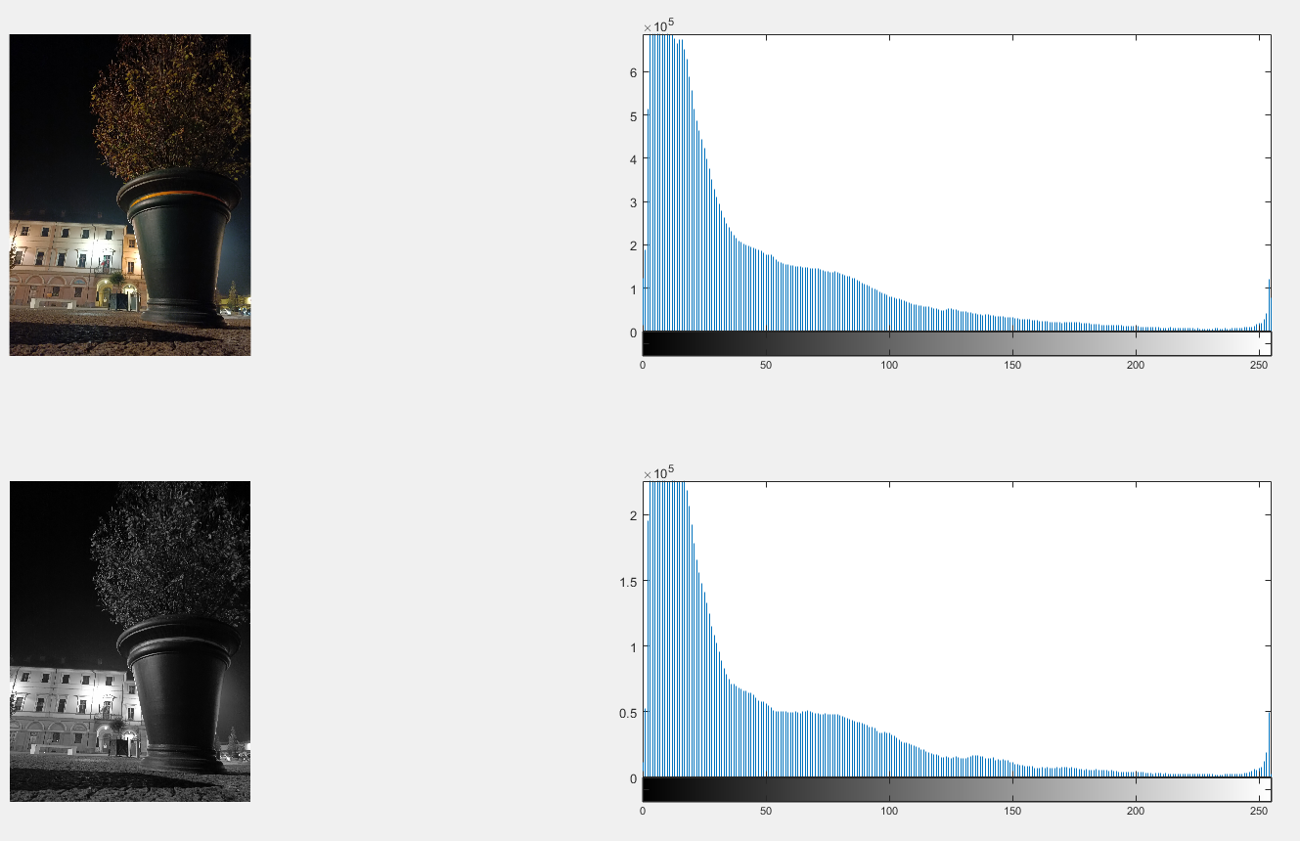

Picture (2.1.1): image gray scale, and histograms

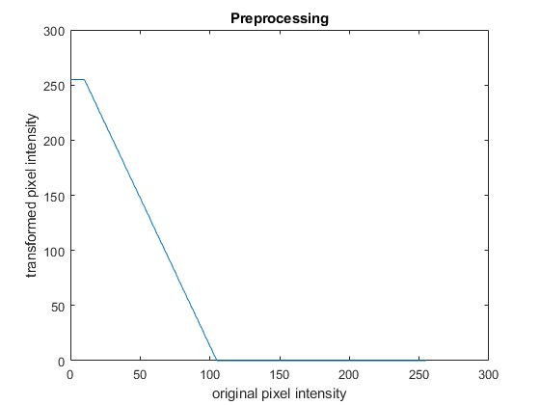

Picture (2.1.2): contrast stretching values

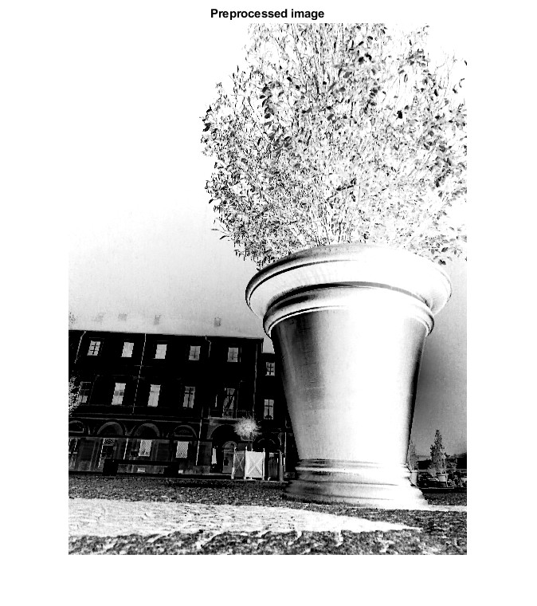

Picture (2.1.2): contrast stretching applied on image

Afterwards, 6 filters from the Matlab computer vision library have been chosen to perform edge detection on the image, the best one would be chosen to manually pick the points on the image, this couldn’t be done automatically, since the conics are not full apparent in the image, thus requiring some intervention in locating the points lying on each conic.

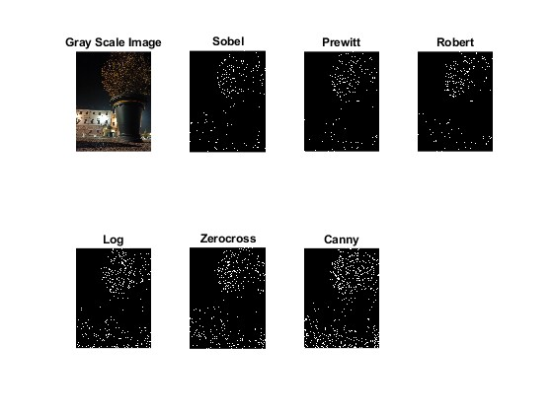

Picture (2.1.3): filters applied on the image

Based on the filters and their performance in detecting edges in the images, the canny filter had been chosen to carry out the mission.

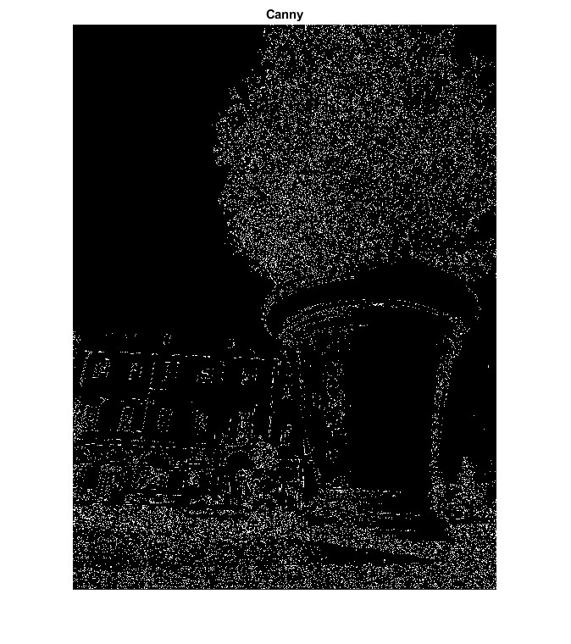

Picture (2.1.4): filter Canny applied on the image

* 1. Conic detection:

The conics have been manually detected as mentioned previously, getting their position in the image alongside their major and minor axis lines, the methods discussed in the theoretical part have been implemented in Matlab in order to solve the 5 questions posed in the problem text.

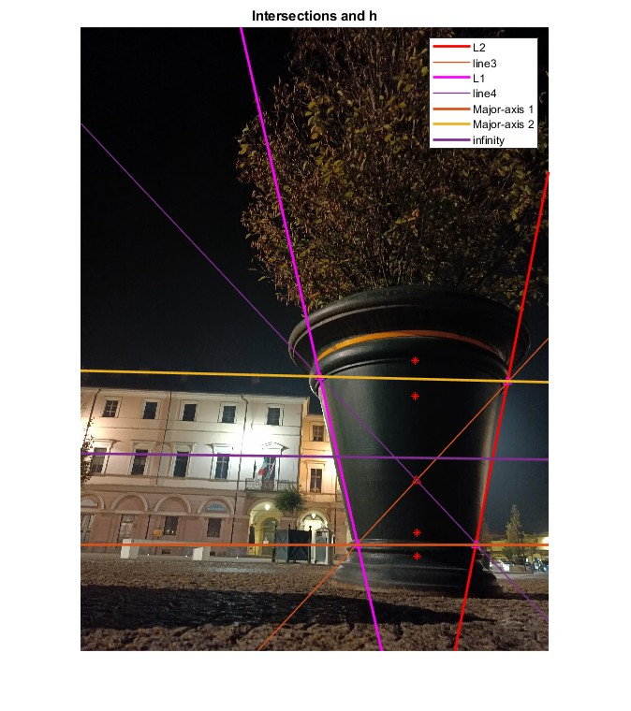

Picture (2.1.4): image of line at infinity from the cone

Also from the theoretical part we can get the calibration matrix K:

Which indicates both the focal length, which is equal in both directions, since the camera is a natural camera with pixel density equal in both directions, and the principal point of the image.

Then we can determine the cone axis orientation with respect to the camera’s reference, assuming that the cone’s axis is perpendicular to the line at infinity:

And then we can conclude the homework with the calculation of the cone’s semi aperture angle, exploiting the rectification of lines:

3 References